**ASSIGNMENT-12.2:**

**A. Consider the schema for Company Database:**

EMPLOYEE (SSN, Name, Address, Sex, Salary, SuperSSN, DNo)

DEPARTMENT (DNo, DName, MgrSSN, MgrStartDate)

DLOCATION (DNo,DLoc)

PROJECT (PNo, PName, PLocation, DNo)

WORKS_ON (SSN, PNo, Hours)

CREATE TABLE EMPLOYEE(SSN VARCHAR(6) PRIMARY KEY, NAME VARCHAR2(30), ADDRESS VARCHAR2(20), SEX VARCHAR(10), SALARY NUMBER(10, 2), SUPERSSN VARCHAR(6), DNO NUMBER(3), FOREIGN KEY(SUPERSSN) REFERENCES EMPLOYEE(SSN), FOREIGN KEY(DNO) REFERENCES DLOCATION(DNO));

**DESC EMPLOYEE;**

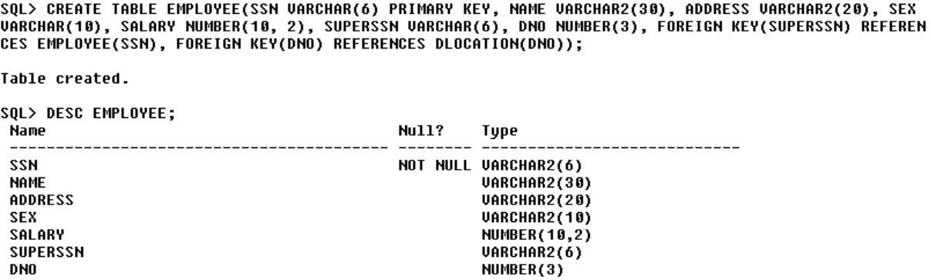

INSERT INTO EMPLOYEE VALUES('E1001', 'TIGER SCOTT', 'KOLKATA', 'MALE', 800000, '', 3);

INSERT INTO EMPLOYEE VALUES('E1002', 'OLIVIA BELL', 'CHENNAI', 'MALE', 1050000, '', 2);

INSERT INTO EMPLOYEE VALUES('E1003', 'ALICE SANDERS', 'KOCHI', 'FEMALE', 1100000, '', 5);

INSERT INTO EMPLOYEE VALUES('E1004', 'GLORIA MURRAY', 'ALLAHABAD', 'FEMALE', 850000, '', 2);

INSERT INTO EMPLOYEE VALUES('E1005', 'EVAN SCOTT', 'DELHI', 'MALE', 1000000, '', 2);

INSERT INTO EMPLOYEE VALUES('E1006', 'RICHARD SHELBY', 'MUMBAI', 'MALE', 1500000, '', 1);

INSERT INTO EMPLOYEE VALUES('E1007', 'DAVE WATSON', 'HYDERABAD', 'MALE', 400000, '', 5);

INSERT INTO EMPLOYEE VALUES('E1008', 'HANNA MARTINEZ', 'KANPUR', 'FEMALE', 950000, '', 5);

INSERT INTO EMPLOYEE VALUES('E1009', 'JULIE EVANS', 'NAGPUR', 'FEMALE', 350000, '', 2);

INSERT INTO EMPLOYEE VALUES('E1010', 'CHRIS BUTLER', 'PATNA', 'MALE', 300000, '', 5);

INSERT INTO EMPLOYEE VALUES('E1011', 'NICOLE GOMEZ', 'MANIPUR', 'FEMALE', 750000, '', 2);

INSERT INTO EMPLOYEE VALUES('E1012', 'JAMES WHITE', 'CHANDIGARH', 'MALE', 500000, '', 5);

INSERT INTO EMPLOYEE VALUES('E1013', 'JOHN PATTERSON', 'VARANASI', 'MALE', 650000, '', 5);

INSERT INTO EMPLOYEE VALUES('E1014', 'CAROLINA TUCKER', 'JAIPUR', 'FEMALE', 550000, '', 2);

**SELECT * FROM EMPLOYEE;**

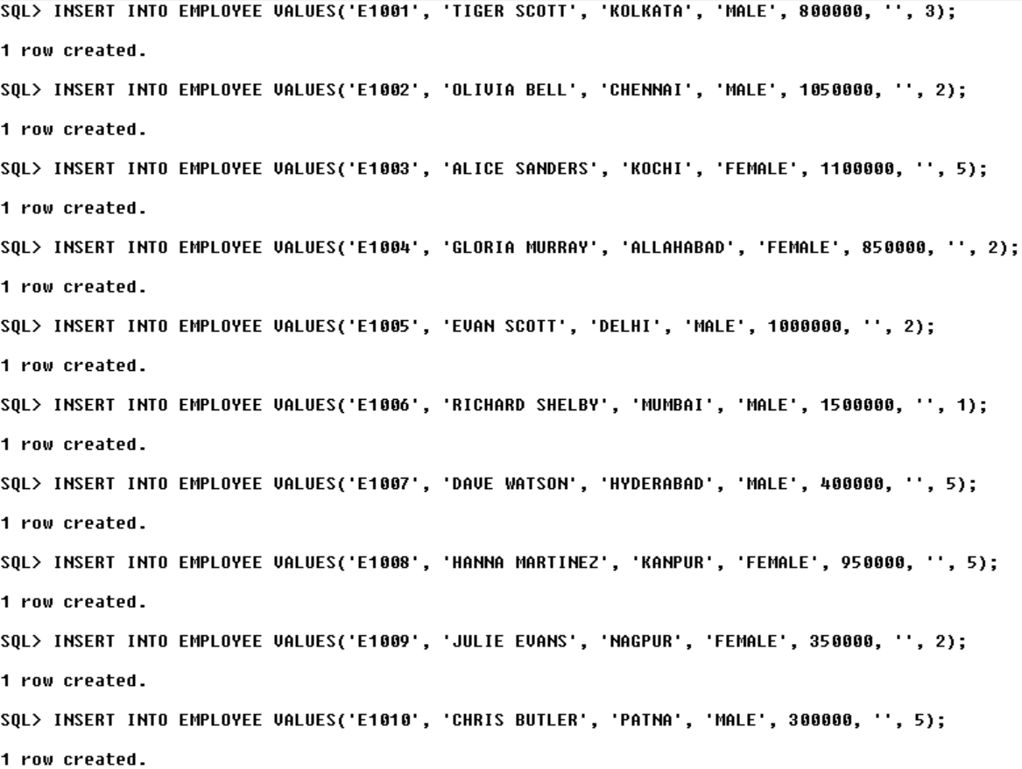

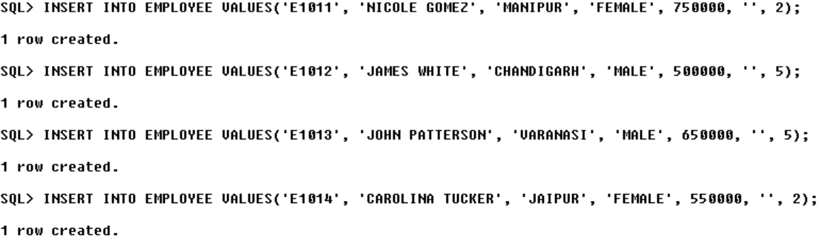

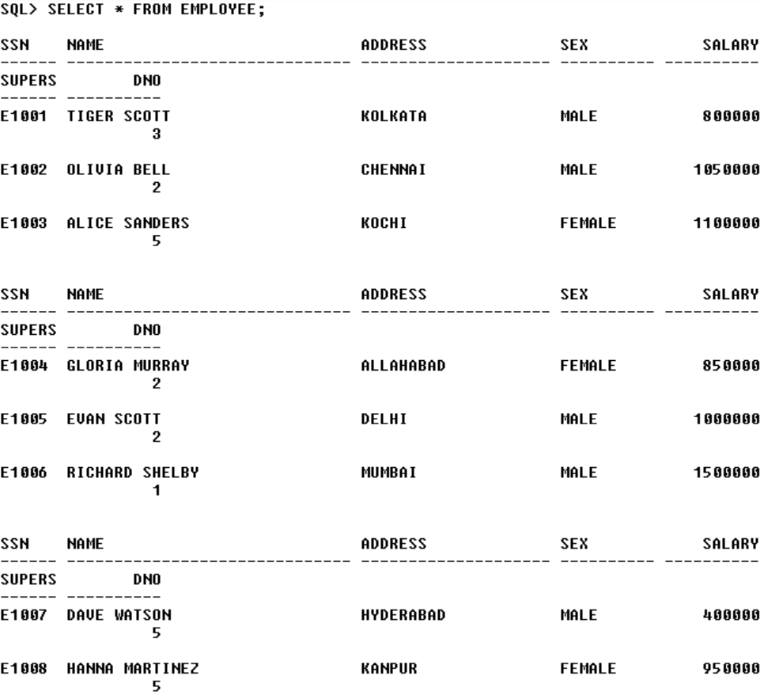

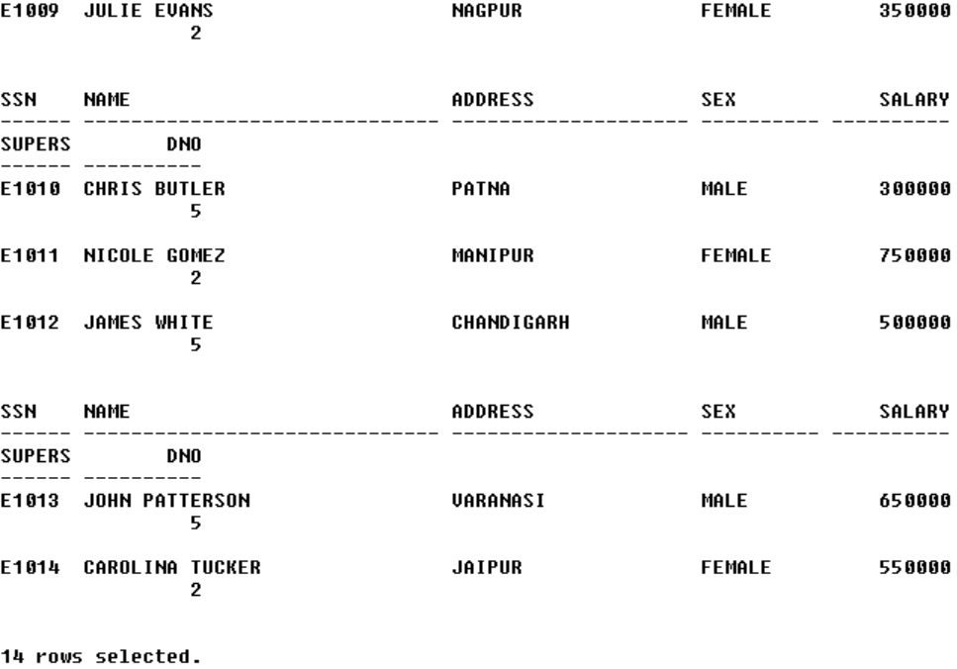

CREATE TABLE DEPARTMENT(DNO NUMBER(3), DNAME VARCHAR2(30), MGRSSN VARCHAR(6), MGRSTARTDATE DATE, FOREIGN KEY(DNO) REFERENCES DLOCATION(DNO), FOREIGN KEY(MGRSSN) REFERENCES EMPLOYEE(SSN));

**DESC DEPARTMENT;**

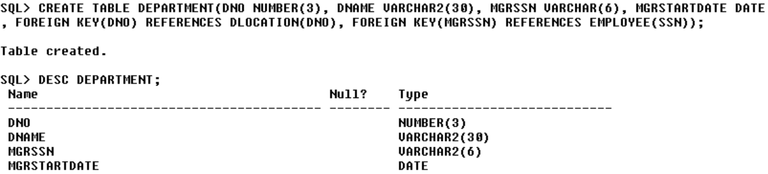

INSERT INTO DEPARTMENT VALUES(1, 'SECURITY', 'E1005', '22-MAY-24');

INSERT INTO DEPARTMENT VALUES(2, 'ACCOUNTS', 'E1009', '10-MAY-24');

INSERT INTO DEPARTMENT VALUES(3, 'TRANSACTIONS', 'E1012', '12-MAY-24');

INSERT INTO DEPARTMENT VALUES(4, 'POLICIES', 'E1003', '01-JUN-24');

INSERT INTO DEPARTMENT VALUES(5, 'ADVERTISEMENT', 'E1011', '15-JUN-24');

**SELECT * FROM DEPARTMENT;**

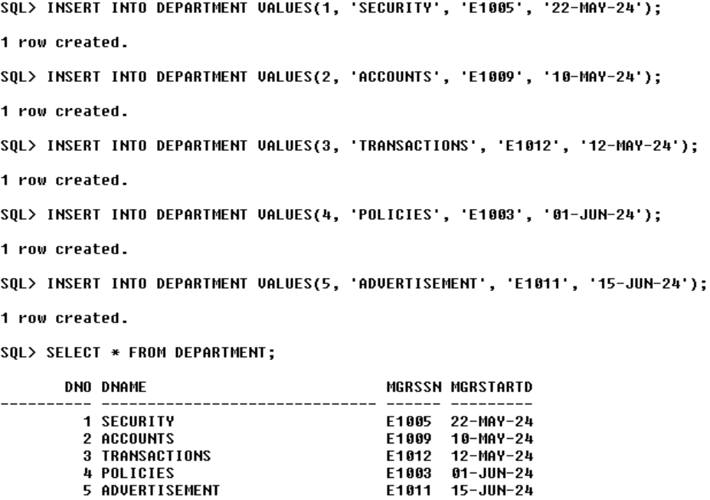

CREATE TABLE DLOCATION(DNO NUMBER(3) PRIMARY KEY, DLOC VARCHAR2(20));

**DESC LOCATION;**

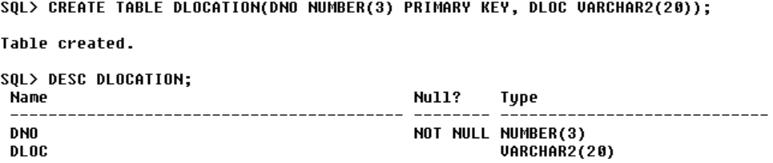

INSERT INTO DLOCATION VALUES(1, 'AHMEDABAD');

INSERT INTO DLOCATION VALUES(2, 'GUWAHATI');

INSERT INTO DLOCATION VALUES(3, 'BENGALURU');

INSERT INTO DLOCATION VALUES(4, 'DELHI');

INSERT INTO DLOCATION VALUES(5, 'MYSORE');

**SELECT * FROM DLOCATION;**

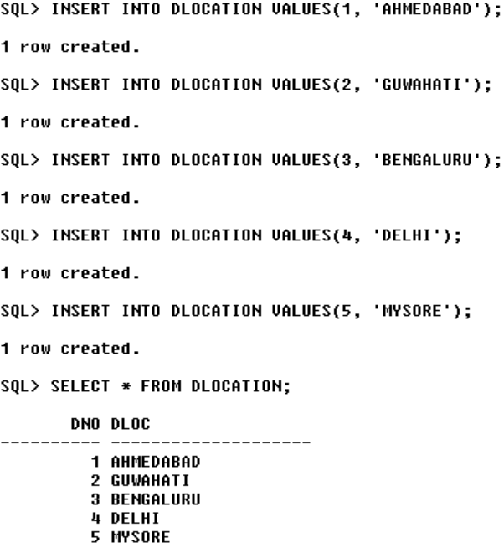

CREATE TABLE PROJECT(PNO VARCHAR(6) PRIMARY KEY, PNAME VARCHAR2(30), PLOCATION VARCHAR2(20), DNO NUMBER(3), FOREIGN KEY(DNO) REFERENCES DLOCATION(DNO));

**DESC PROJECT;**

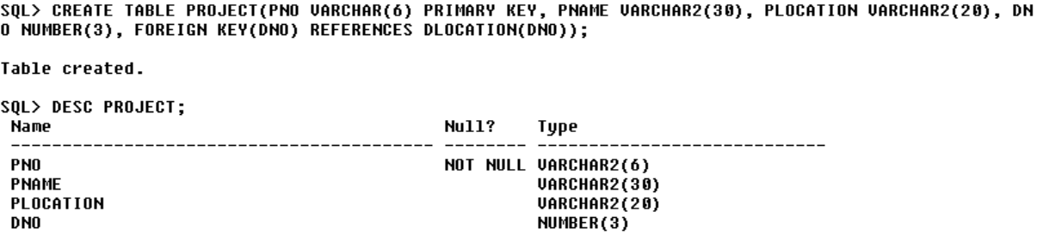

INSERT INTO PROJECT VALUES('P3001', 'AI', 'CHENNAI', 3);

INSERT INTO PROJECT VALUES('P3002', 'ML', 'DELHI', 5);

INSERT INTO PROJECT VALUES('P3003', 'WEB DEVELOPMENT', 'DELHI', 1);

INSERT INTO PROJECT VALUES('P3004', 'IOT', 'INDORE', 2);

INSERT INTO PROJECT VALUES('P3005', 'BLOCKCHAIN', 'GOA', 5);

INSERT INTO PROJECT VALUES('P3006', 'SOCIAL NETWORKING', 'PUNE', 4);

**SELECT * FROM PROJECT;**



CREATE TABLE WORKS_ON(SSN VARCHAR(6), PNO VARCHAR(6), HOURS NUMBER(10, 2), FOREIGN KEY(SSN) REFERENCES EMPLOYEE(SSN), FOREIGN KEY(PNO) REFERENCES PROJECT(PNO));

**DESC WORKS_ON;**

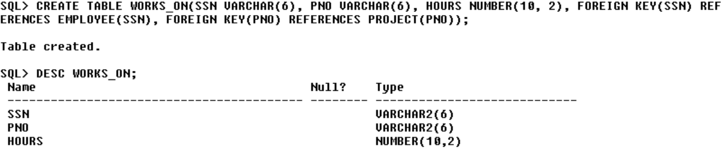

INSERT INTO WORKS_ON VALUES('E1001', 'P3002', 100);

INSERT INTO WORKS_ON VALUES('E1002', 'P3005', 80);

INSERT INTO WORKS_ON VALUES('E1002', 'P3002', 160);

INSERT INTO WORKS_ON VALUES('E1004', 'P3001', 110);

INSERT INTO WORKS_ON VALUES('E1006', 'P3006', 170);

INSERT INTO WORKS_ON VALUES('E1007', 'P3002', 200);

INSERT INTO WORKS_ON VALUES('E1007', 'P3005', 120);

INSERT INTO WORKS_ON VALUES('E1008', 'P3004', 50);

INSERT INTO WORKS_ON VALUES('E1010', 'P3003', 180);

INSERT INTO WORKS_ON VALUES('E1013', 'P3004', 90);

INSERT INTO WORKS_ON VALUES('E1014', 'P3003', 140);

**SELECT * FROM WORKS_ON;**

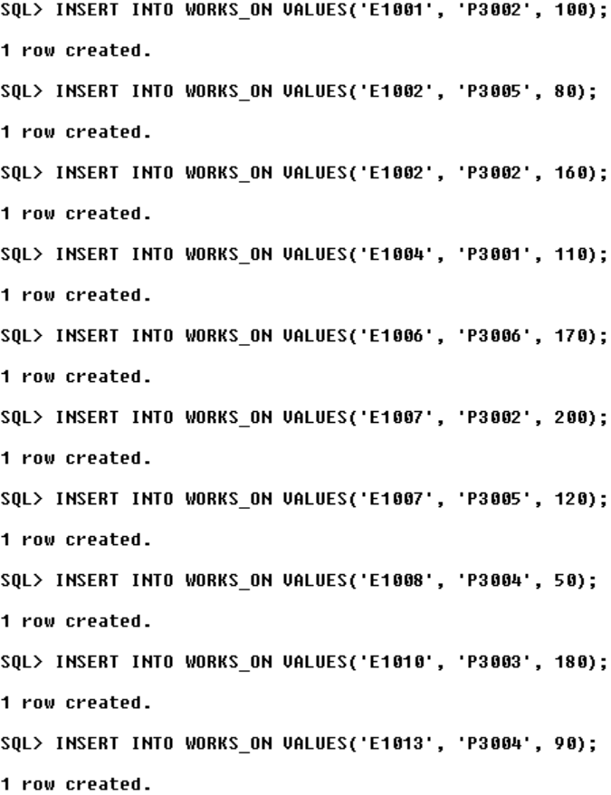

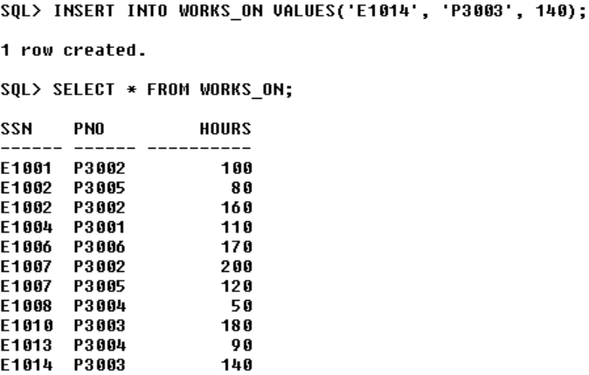

**-- SQL Queries --**

**1. Make a list of all project numbers for projects that involve an employee whose last name is ‘Scott’, either as a worker or as a manager of the department that controls the project.**

(SELECT P.PNO FROM PROJECT P JOIN WORKS_ON W ON P.PNO=W.PNO JOIN EMPLOYEE E ON W.SSN=E.SSN WHERE NAME LIKE '% SCOTT') UNION (SELECT P.PNO FROM PROJECT P JOIN DEPARTMENT D ON P.DNO=D.DNO JOIN EMPLOYEE E ON D.MGRSSN=E.SSN WHERE NAME LIKE '% SCOTT');

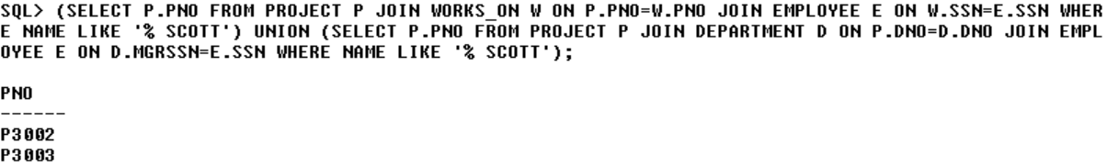

**2. Show the resulting salaries if every employee working on the ‘IoT’ project is given a 10 percent raise.**

SELECT SALARY*1.1 AS NEW_SALARY FROM PROJECT P JOIN WORKS_ON W ON P.PNO=W.PNO JOIN EMPLOYEE E ON W.SSN=E.SSN WHERE PNAME='IOT';

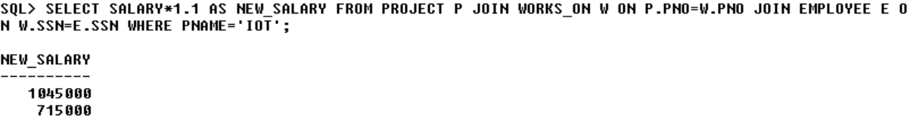

**3. Find the sum of the salaries of all employees of the ‘Accounts’ department, as well as the maximum salary, the minimum salary, and the average salary in this department**

SELECT SUM(SALARY) AS SUM_SALARY, MAX(SALARY) MAX_SALARY, MIN(SALARY) AS MIN_SALARY, AVG(SALARY) AS AVG_SALARY FROM EMPLOYEE E JOIN DEPARTMENT D ON E.DNO=D.DNO WHERE DNAME='ACCOUNTS';

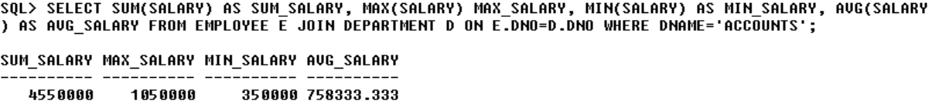

**4. Retrieve the name of each employee who works on all the projects controlled by department number 5 (use NOT EXISTS operator).**

SELECT DISTINCT NAME FROM EMPLOYEE E JOIN WORKS_ON W ON E.SSN=W.SSN WHERE NOT EXISTS (SELECT DISTINCT P.PNO FROM PROJECT P JOIN WORKS_ON W2 ON P.PNO=W2.PNO WHERE P.DNO=5 AND P.PNO NOT IN (SELECT PNO FROM WORKS_ON WHERE SSN=E.SSN));

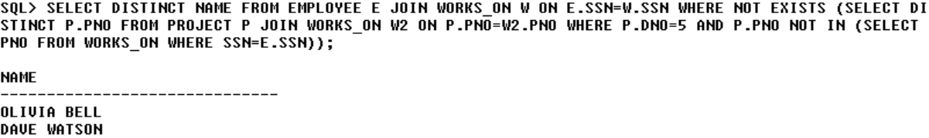

**5. For each department that has more than five employees, retrieve the department number and the number of its employees who are making more than Rs. 6,00,000.**

SELECT DNO, COUNT(*) FROM (SELECT E.DNO, E.SALARY FROM EMPLOYEE E WHERE (SELECT COUNT(*) FROM EMPLOYEE WHERE DNO=E.DNO)>5 AND E.SALARY>600000) GROUP BY DNO;

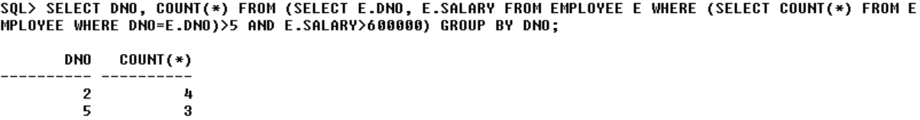

**B. Write a program in PL/SQL to create a procedure to displays the GCD of nos.**

DECLARE

N1 NUMBER(10);

N2 NUMBER(10);

GCD NUMBER(10);

I NUMBER(10);

BEGIN

N1:=&N1;

N2:=&N2;

FOR I IN 1..N1

LOOP

IF MOD(N1,I) = 0 AND MOD(N2,I) = 0 THEN

GCD:=I;

END IF;

END LOOP;

DBMS_OUTPUT.PUT_LINE('GCD=' || GCD);

END;

/

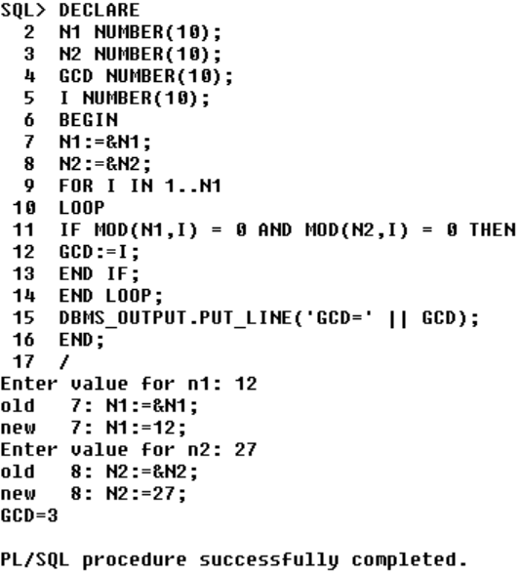

**C. Write a program in PL/SQL to create a cursor displays the name and salary of each employee in the EMPLOYEES table whose salary is less than that specified by a passed-in parameter value.**

DECLARE

SALBOUND EMPLOYEE.SALARY%TYPE;

C_NAME EMPLOYEE.NAME%TYPE;

C_SALARY EMPLOYEE.SALARY%TYPE;

CURSOR C_EMPLOYEE IS

SELECT NAME, SALARY FROM EMPLOYEE;

BEGIN

SALBOUND:=&SALBOUND;

OPEN C_EMPLOYEE;

LOOP

FETCH C_EMPLOYEE INTO C_NAME, C_SALARY;

EXIT WHEN C_EMPLOYEE%NOTFOUND;

IF C_SALARY<SALBOUND THEN

DBMS_OUTPUT.PUT_LINE(C_NAME || ' ' || C_SALARY);

END IF;

END LOOP;

CLOSE C_EMPLOYEE;

END;

/

